Chapter 12, Problem 59.

The source in Fig. 12.65 is balanced and exhibits a positive phase sequence.
If f = 60 Hz, use Pspice to find V_{AN}, V_{BN}, and V_{CN}.

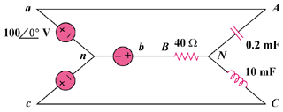

Figure 12.65
For Prob. 12.59.

